## Audio on LinkIt Smart 7688

[Linkit 7688 DUO有一個I2S介面，我們可以用它來開發音頻應用。要得到音頻信號的工作，需要額外的硬體，例如，從Seeed的介面板。](https://github.com/xiongyihui/LinkIt_Smart_7688/blob/master/README.md)

或USB音效卡

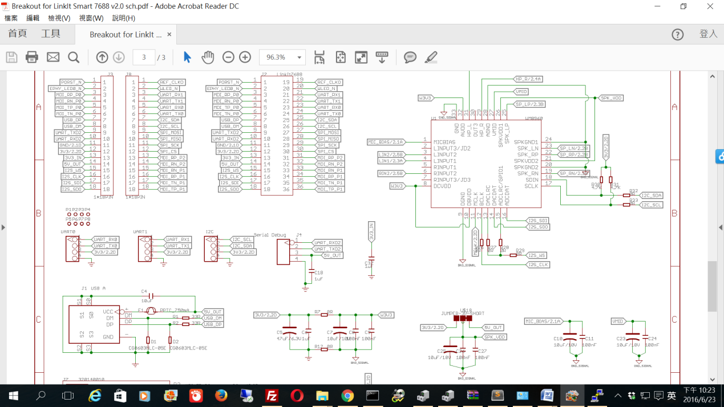

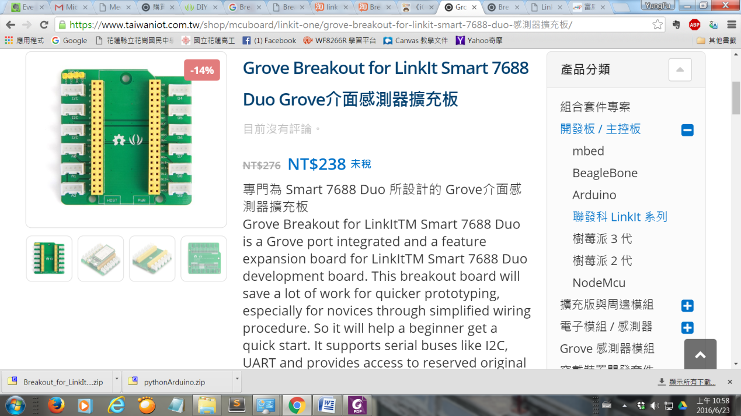

[透過USB更新 firmware](http://www.gibar.co/2016/01/linkit-7688-duo-firmware-update.html)

## 

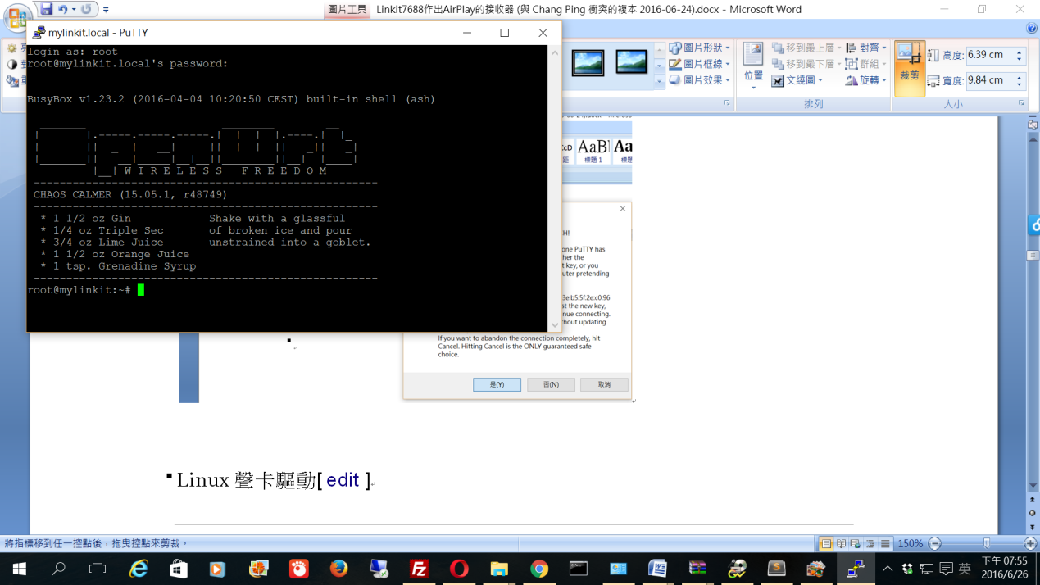

check Audio device

aplay -l

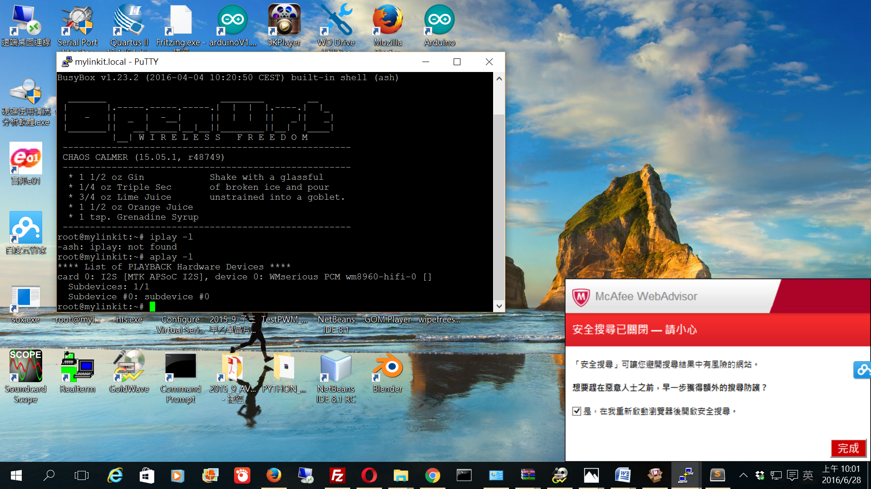

OpenWrt的安裝USB聲卡驅動程式

opkg update

opkg install kmod-sound-core (linkit 7688 duo預安裝)

opkg install kmod-usb-audio

opkg install madplay (linkit 7688 duo預安裝)

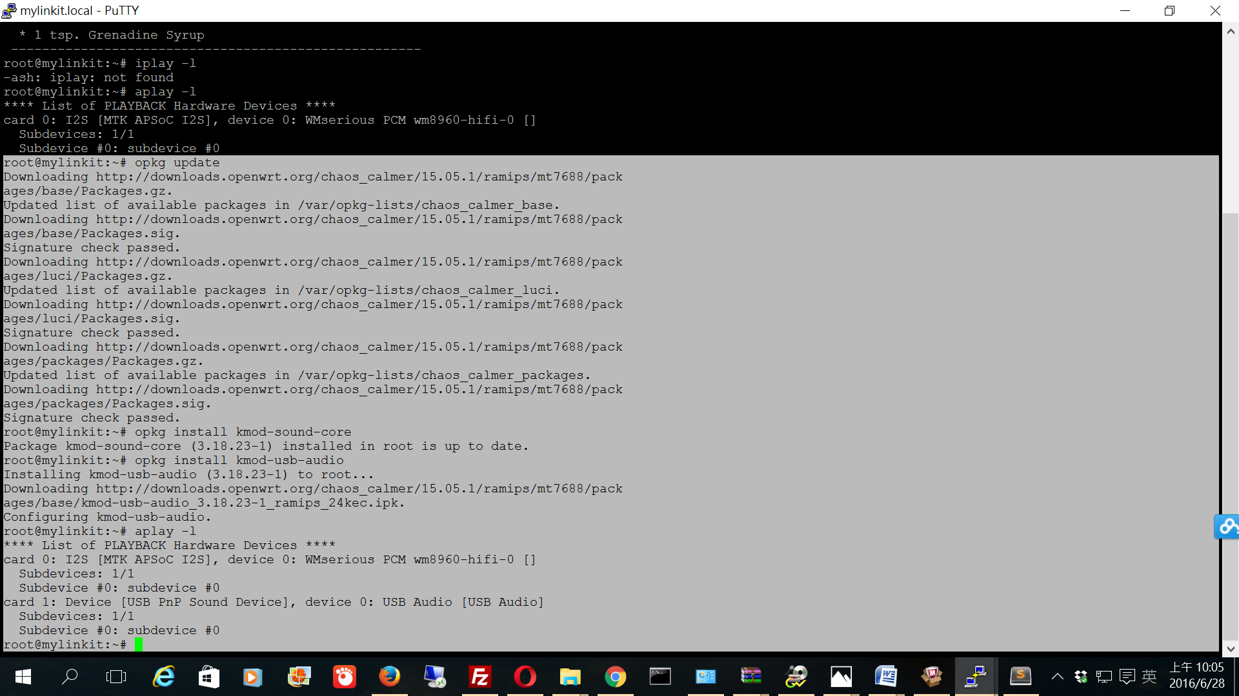

usb sound card

播放網絡收音機數據流

wget -O - http://50.7.96.210:8360 | madplay - -a+5 -o wave:- | aplay -D plughw:1

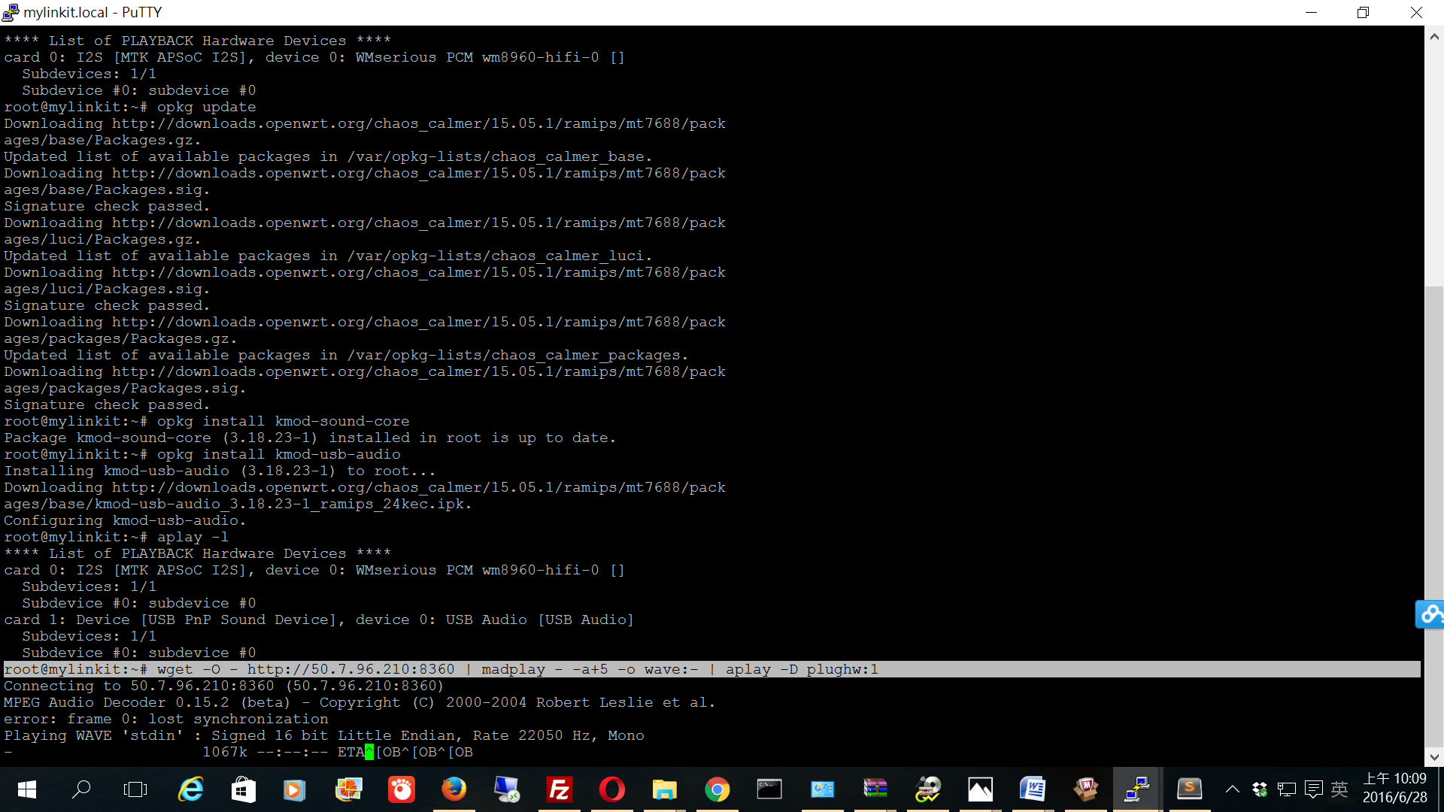

更改默認alsa.conf音頻輸出設備

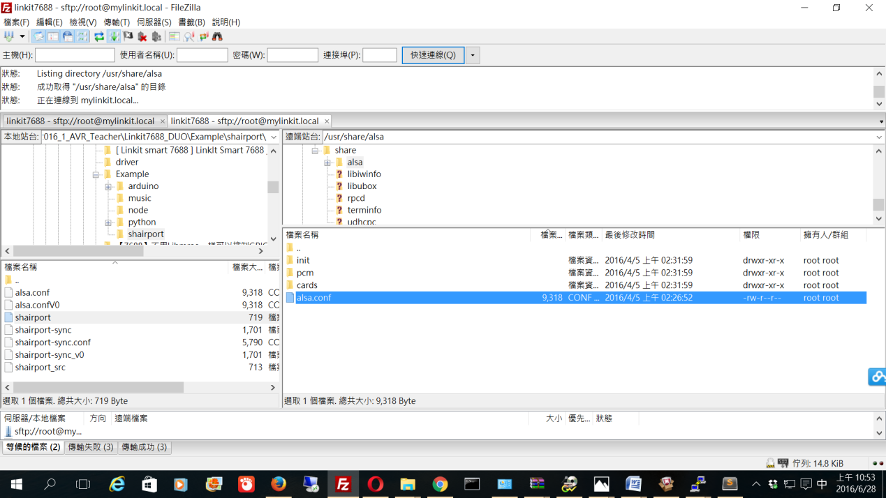

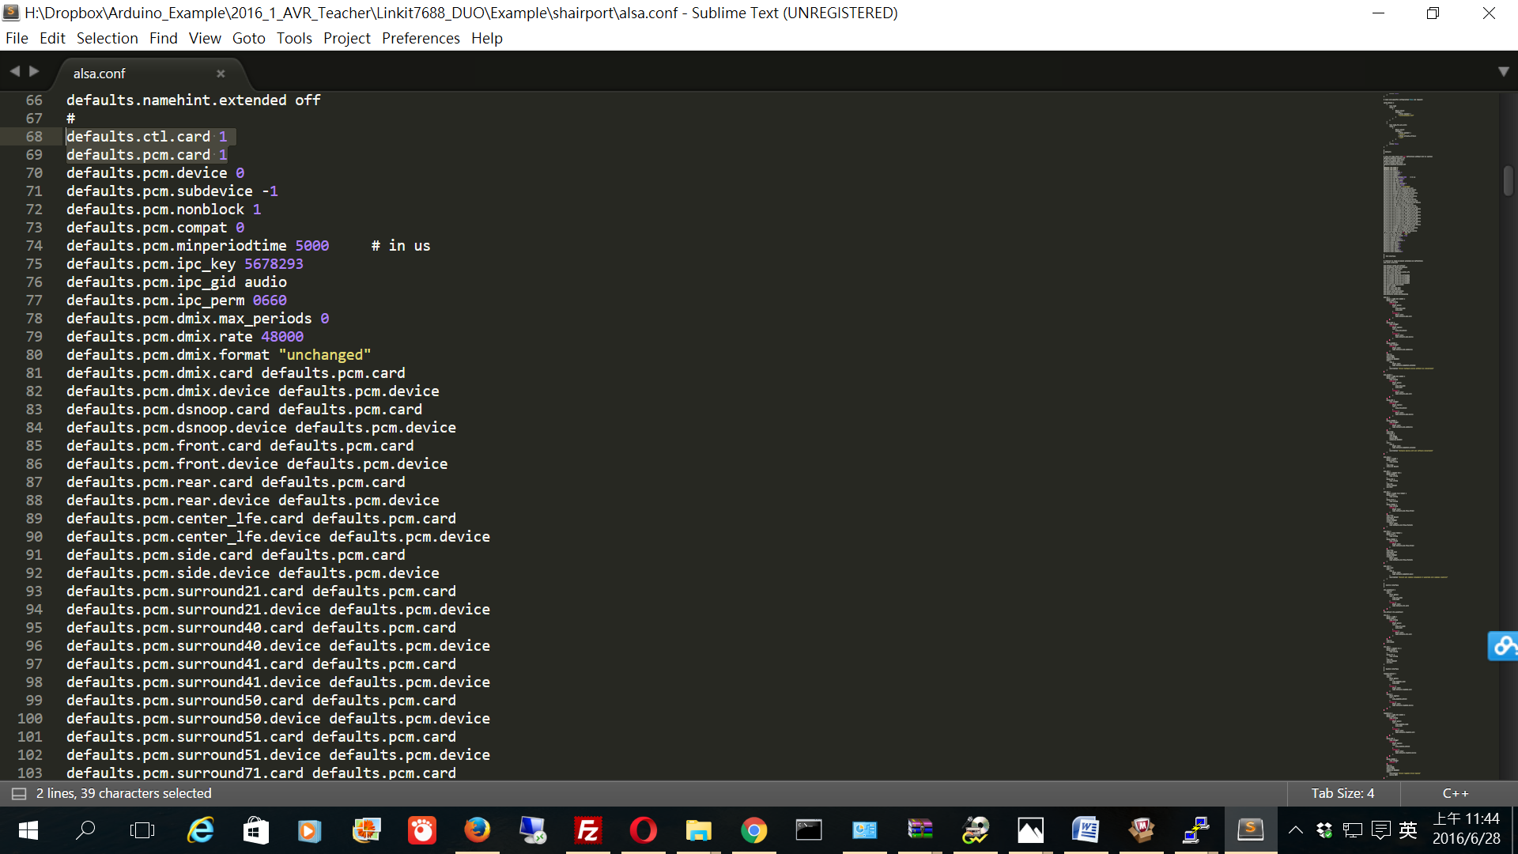

0-->1

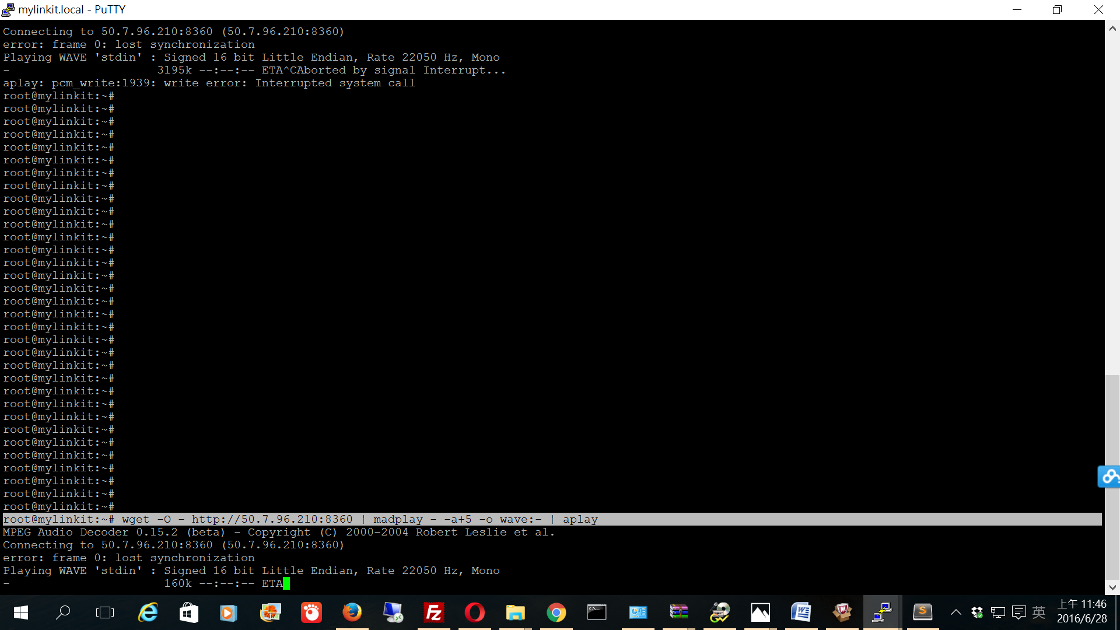

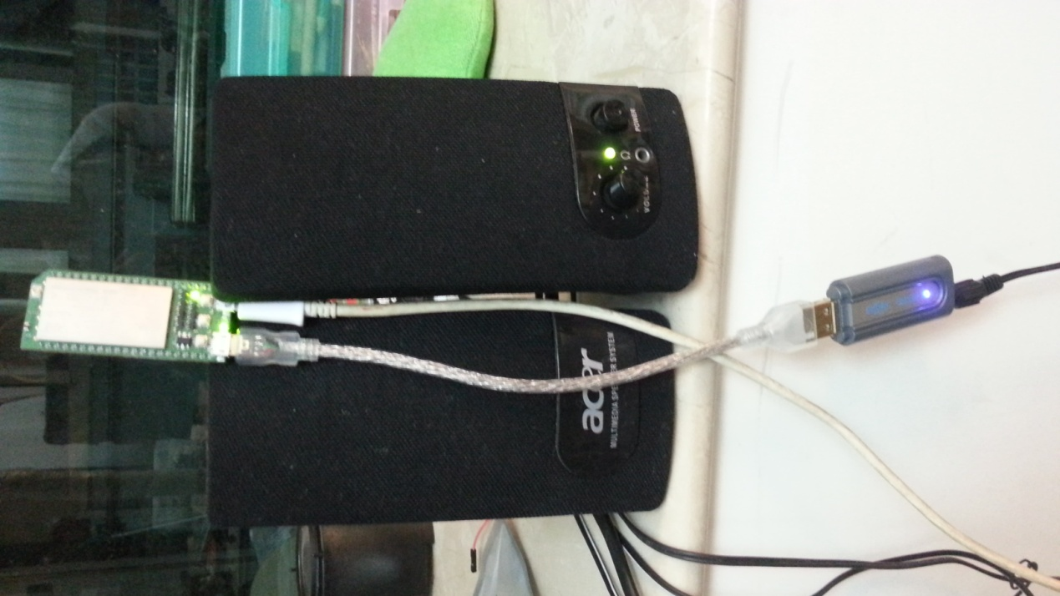

speaker amplifier

usb sound card

OTG

[//----------------------------Airplay](https://github.com/xiongyihui/LinkIt_Smart_7688/blob/master/README.md)

<https://github.com/abrasive/shairport>

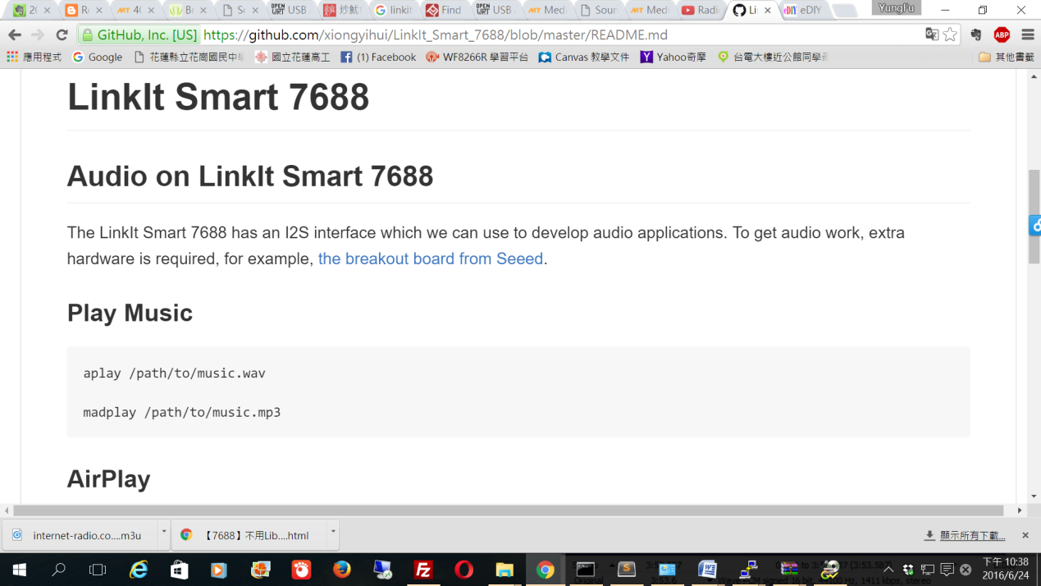

1 Shairport

We patch shairport with [002-use_mmap.patch](https://github.com/xiongyihui/LinkIt_Smart_7688/blob/master/shairport_patch/002-use_mmap.patch), use mmap to improve the performance and package [a new revision shairport ipk](https://github.com/xiongyihui/LinkIt_Smart_7688/blob/master/shairport_2014-10-28-2_ramips_24kec.ipk).

download shairport_2014-10-28-2_ramips_24kec.ipk to PC

copy shairport_2014-10-28-2_ramips_24kec.ipk to /tmp

# Enable sftp, work around https://trac.cyberduck.io/ticket/4161

opkg update

opkg install openssh-sftp-server

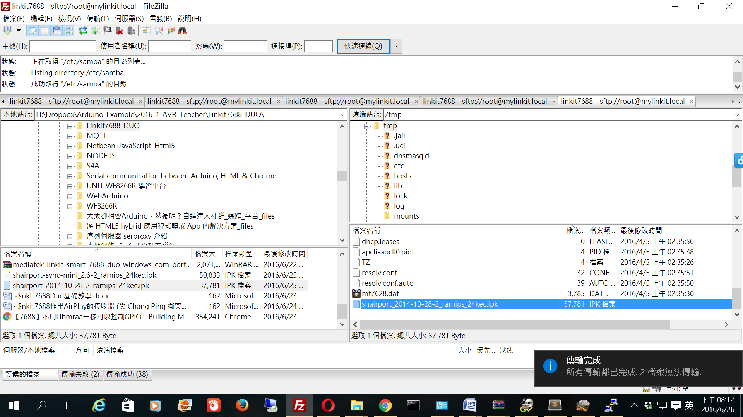

opkg update

opkg install libdbus

opkg install /tmp/shairport_2014-10-28-2_ramips_24kec.ipk --force-checksum --force-overwrite

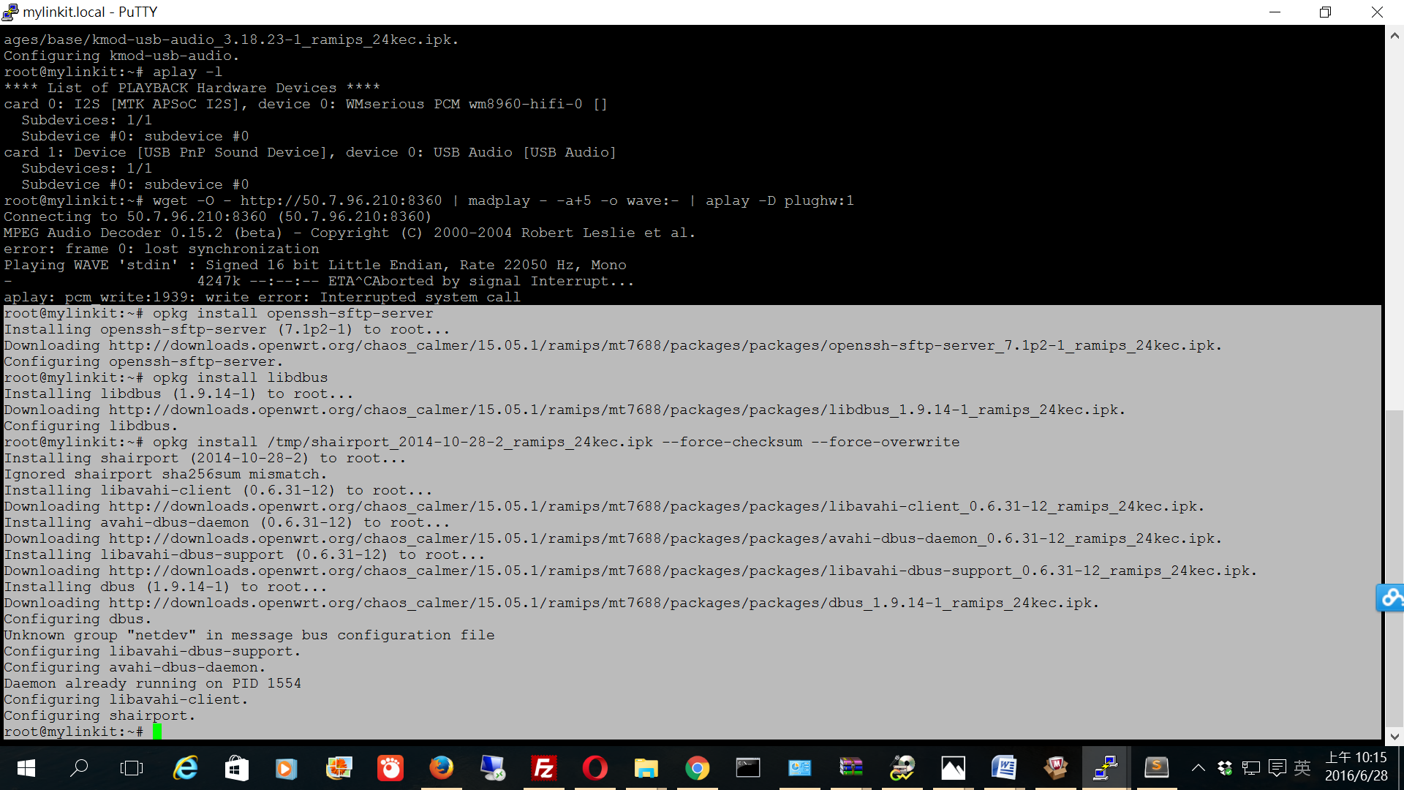

shairport

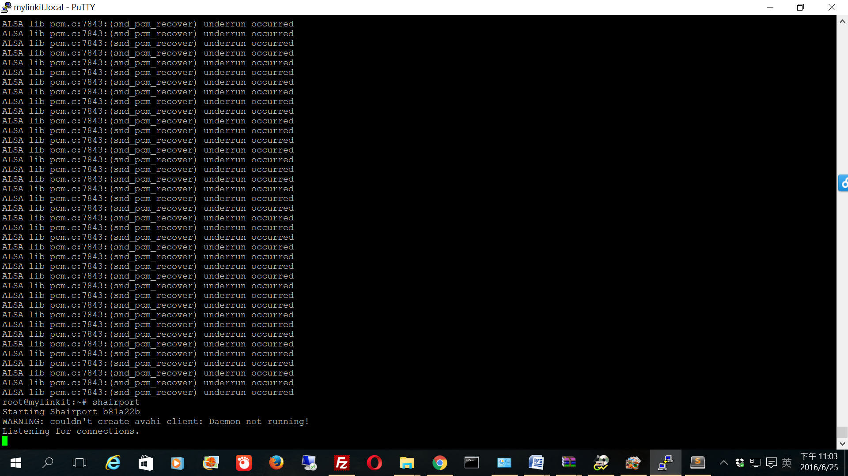

用iPad(audials app)設置airplay接收器

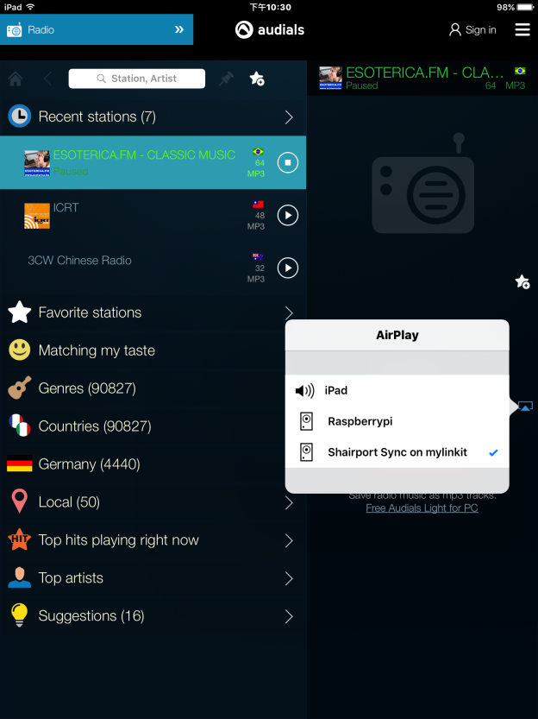

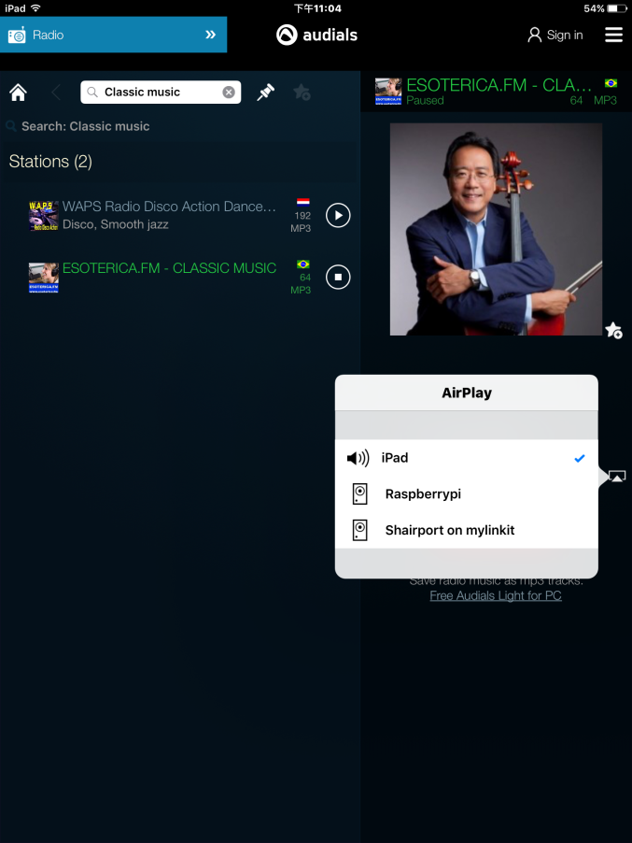

如果不改變默認alsa.conf音頻輸出設備

當iPad連接linkit7688 DUO==>(snd_pcm_recover）發生數據不足錯誤

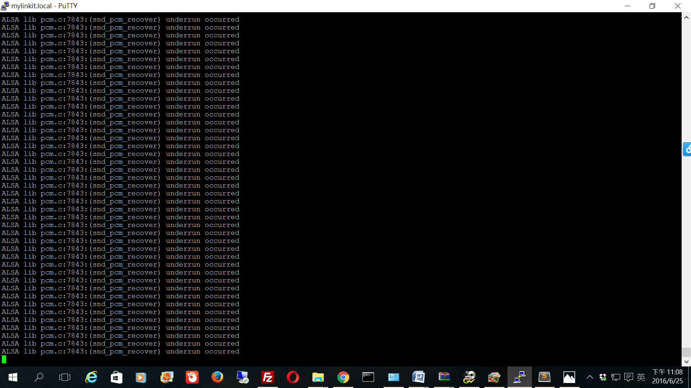

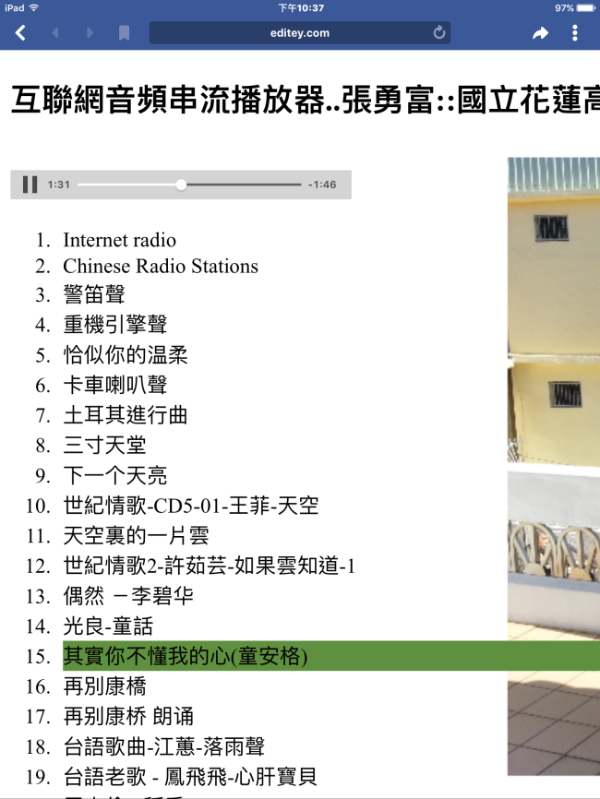

## [互聯網音頻串流播放機..張勇富::國立花蓮高級工業職業學校](http://www.editey.com/preview/0B_lFhYyj4JwRSDZYenNQcUxjNms/Audio_ex2.2.html?email=changleeyipun%40gmail.com)

測試成功2016/6/28

最後我們設置開機啟動

/etc/init.d/dbus enable

/etc/init.d/avahi-daemon enable

/etc/init.d/shairport enable(開機啟動,don't work)

reboot

reboot 測試

wget -O - http://50.7.96.210:8360 | madplay - -a+5 -o wave:- | aplay(測試成功)

shairport -a "chang airplay" -d ==>(#在後台運行

, 手動啟動成功)

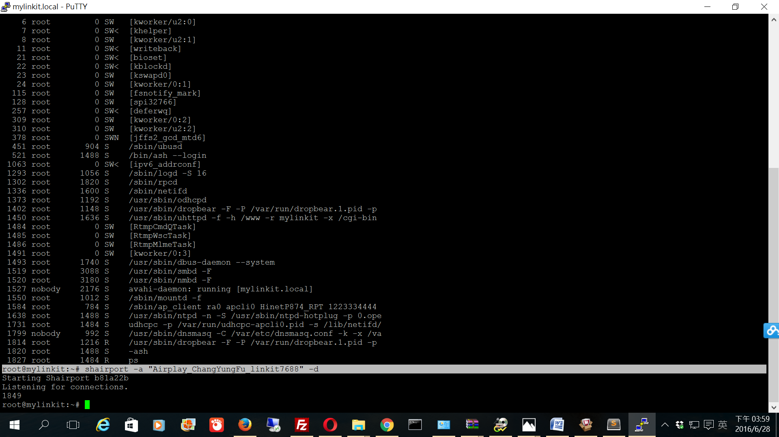

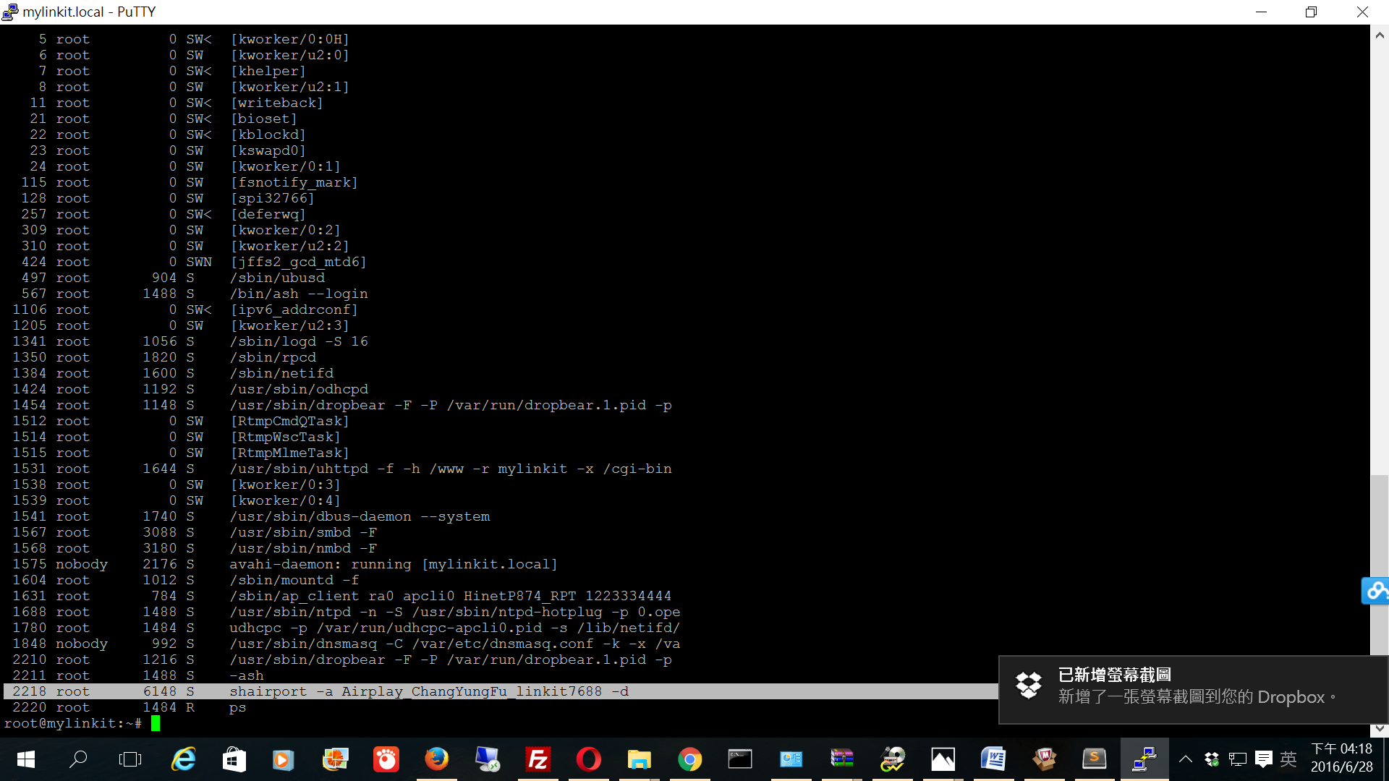

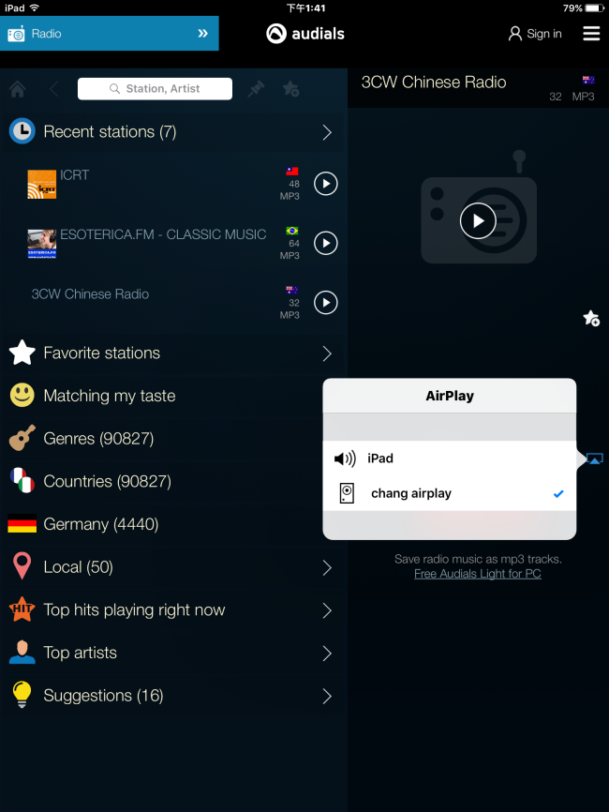

[**Openwrt設置開機啟動**](http://www.jianshu.com/p/20881a8b6e02)

建議使用shairport-sync